Revolution Recycling Cart Service in Du Quoin and Pinckneyville
We provide 95 gallon carts for Cardboard and Mixed Paper, and 65 gallon carts for Glass, Metal, and Plastic 1 & 2 (bottles, cans, and jugs). We will mark 65 gallon carts for paper if desired for space/handling. The number and type of carts can be adjusted anytime to fit the current recycling stream.
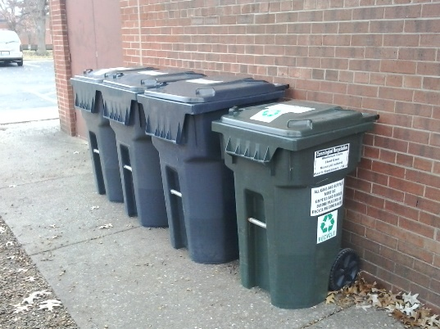
All carts delivered will require a $50 deposit, refundable pending paid in full account balance. Established businesses or government entities can be invoiced for deposit. Customers can purchase compatible carts (2 bar US) independently if they wish. RR will provide decals for carts we service.
Cart Service Rates are:
1-2 Carts @ $5 each per service
3-5 Carts @ $4 each per service
6 or more Carts @ $3 each per service
Billing is by number of carts subscribed. Material must be in Carts. All carts presented at the agreed collection point by 7 am will be serviced by 7 pm. Call in service (by voice, voice message, text, email, or USPO) requires at least 24 hour receipt of your notice prior to route day. We must have adequate truck access to service. We do not require contracts, and there are no other fees or taxes.
All services require adherence to material separation, preparation, and instructions as provided.
Mike Huskey, Revolution Recycling, Established 2008
877 316 1776 or 618 525 0525 RecycleWhereYouWork@gmail.com, RecycleWhereYouWork.com

