Revolution Recycling Roll Off Services
In Du Quoin $157 per load, one load per month minimum. Container provided no charge.
In Pinckneyville $201 per load, one load per month minimum. Container provided no charge.
All loads are scaled and reported on monthly invoices. Containers are 8’ wide x 16’ long or 8’ x 20”. Covered/split containers are marked for two stream recycling. Bottles, Cans, and Jugs are mixed. Cardboard and paper are mixed. Open top containers are also available at the same rates for large volume generators (cardboard usually). The 16’ containers can be sited/fit in a standard parking space. The hauling rate quoted is based on Southern Recycling as destination. Customers who own compatible RO containers are not subject to minimum.
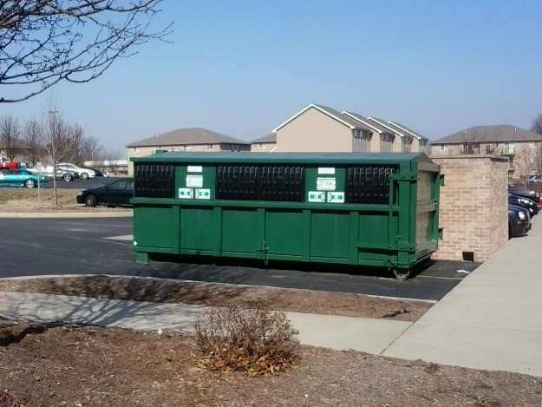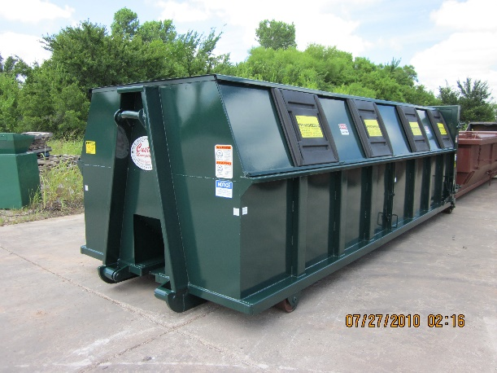
We currently have RO containers in stock ready to go. Contracts and deposits are not required. There are never any “other fees” added to our services. We serve a wide variety of business, government, HOA, and non-profit RO accounts in Southern Illinois. We are a local independent small business established in 2008.
Mike Huskey
Revolution Recycling
877 316 1776 or call direct 618 525 0525
RecycleWhereYouWork@gmail.com
RecycleWhereYouWork.Com

